Bryan Chan

CS 340

Prof. Othman

18 August 2024

Project Two

**Describe the required functionality**

* **In order to fulfill the requirements of the project, the program must: 1) Contain the Gravioso Salvare logo which will redirect the user to the main site (**[www.snhu.edu](http://www.snhu.edu/)**); 2) Interactive buttons which will filter the items in the dashboard; and 3) An interactive pie graph which will change depending on the filter option.**



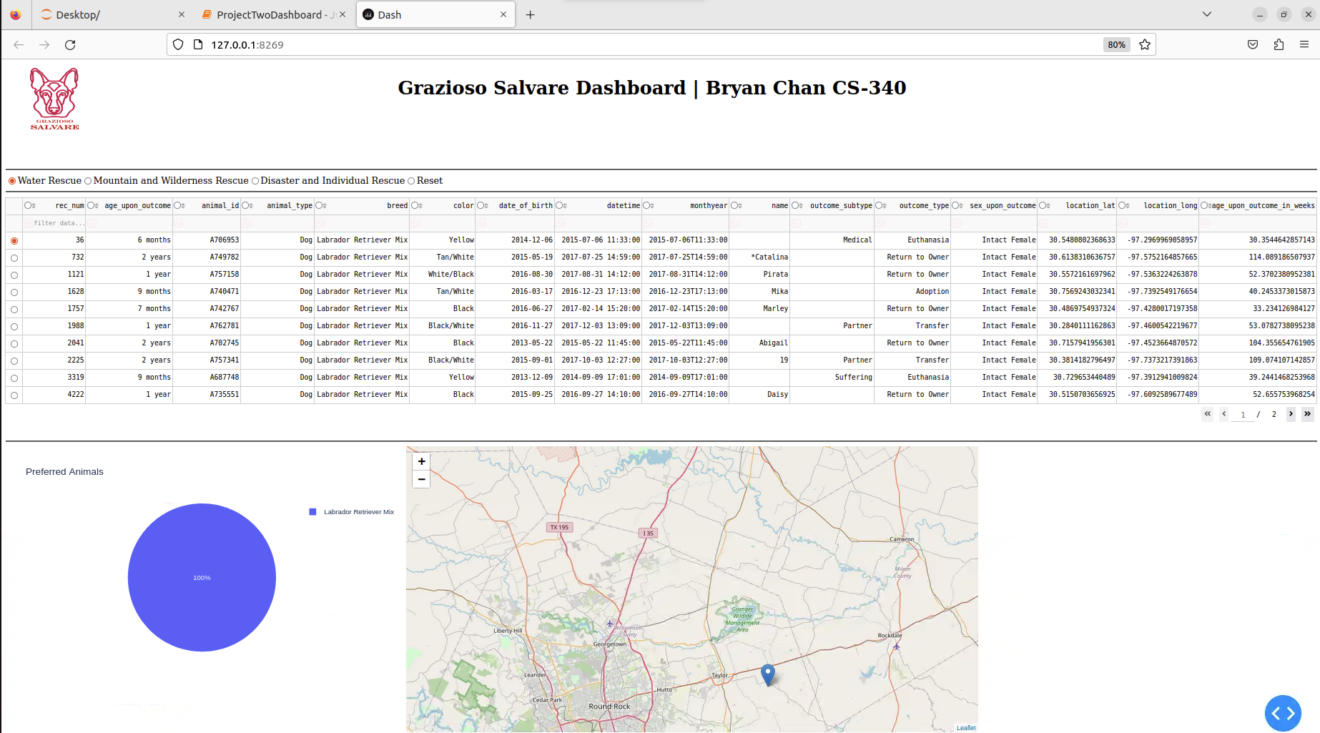

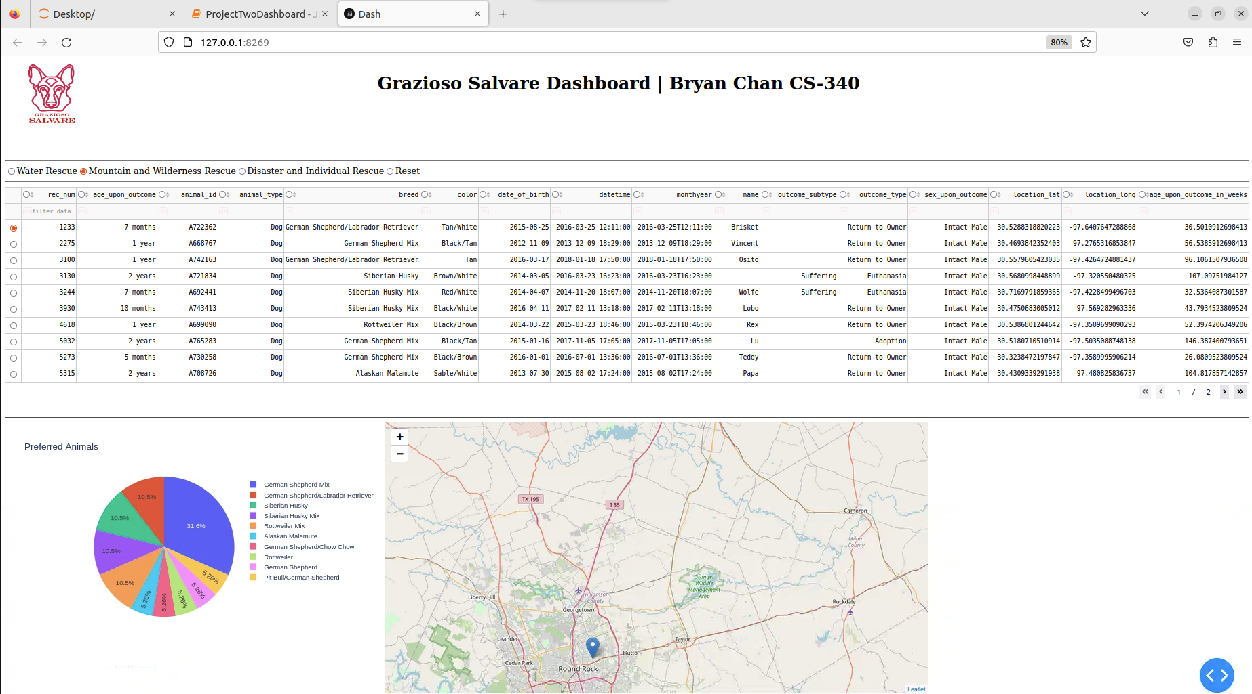

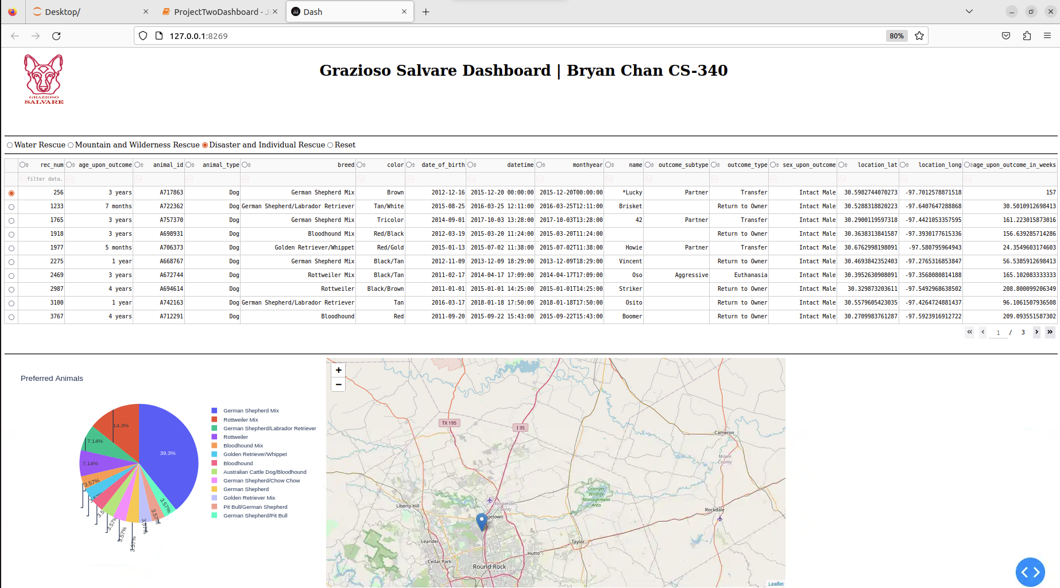

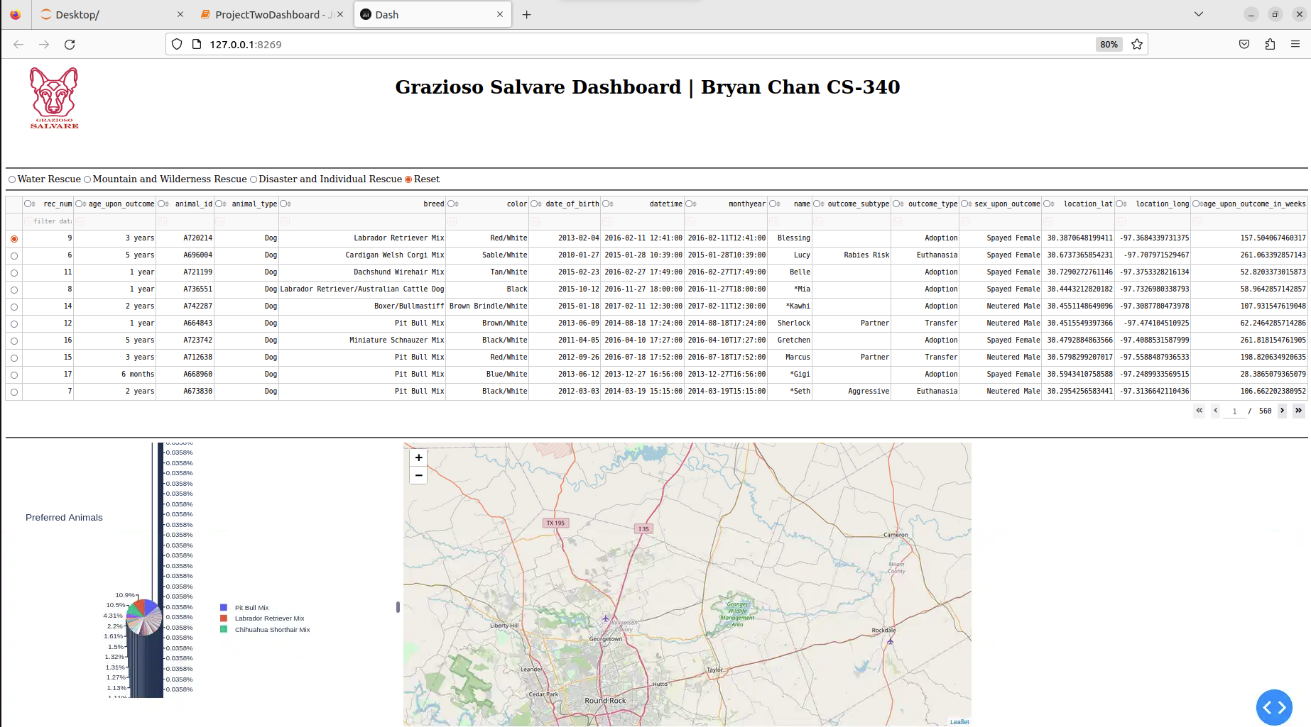

**Describe the tools used to achieve this functionality and a rationale for why these tools were used**

* **For this project, a number of tools were used during development. They are as follows: Python, MongoDB, Jupyter_Dash, Dash, and Plotly. Python was the main programming language in this project. It powered the CRUD module, “AnimalShelter.py”, which provided the functionality for the dashboard. MongoDB was the database of choice. MongoDB proved to be the perfect choice for this type of application, since MongoDB being a noSQL database, organizes data in a document format. For the interactive dashboard, Jupyter_Dash was used to implement the functionalities of the Dash library into a Jupyter notebook. Speaking of which, the Dash library enabled the dashboard to contain HTML elements and components, while using Python. The Dash library was the main tool behind the view-side of the program. Lastly, for the interactive pie graph, the Plotly library was used to create the graph.**
* **Tools link:**
  + **Python: https://www.python.org/**
  + **MongoDB: https://www.mongodb.com/**
  + **Jupyter_Dash: https://dash.plotly.com/dash-in-jupyter**
  + **Dash: https://dash.plotly.com/**
  + **Plotly: https://plotly.com/**

**Explain the steps that were taken to complete the project**

* **In order to complete this project, I had to download the given “ProjectTwoDashboard.ipynb” file, and implement the required features. First, I had to instantiate the CRUD module “AnimalShelter.py” into the dashboard. After doing so, I began to implement the logo. To do so, I wrapped the Gravioso Salvare logo into an anchor tag using Dash, which would direct the user to “**[www.snhu.edu](http://www.snhu.edu/)**” when clicked. Then, I added the radio buttons (again using the Dash library). The radio buttons contain predefined values, which would change the logic of the interactive graphs depending on which button is pressed. Lastly, I added an interactive pie graph, which would change depending on the filter option. The graph was made using Plotly, which is a sub-library of Dash.**

**Identify any challenges that were encountered and explain how those challenges were overcome**

* **One of the challenges of the project, was troubleshooting the dashboard. At first, the dashboard would not load the data in the “AAC” database. After much troubleshooting, it was discovered that the errors were caused by the CRUD module, “AnimalShelter.py”. In particular, the read() method, when given an empty directory, was supposed to return every document in the database. The read() method was doing this. However, instead of inserting every document into a single list, every documents were placed as a single element in a list. This was causing issues for the dashboard. After fixing this bug, the dashboard was able to display every document from the database.**